UX Testing Report for Fansportiz:
1. Complaints: Improve Accuracy, Reduces miscommunication between users and support teams.
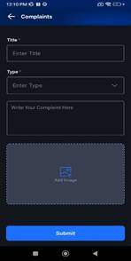
- Video Reports: Users can visually demonstrate issues, leading to faster resolutions.
- Shake and Report: A quick and effortless way to report bugs without navigating through menus.
2. Wallet details – Ensure that when users click on the (i) icon for 'Cash Bonus' details, the pop-up does not hide the 'Add Cash' button.
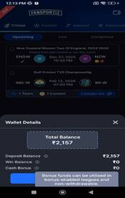

- Improves Usability: Users can view wallet details without losing access to the 'Add Cash' button.
- Enhances Navigation: Avoids unnecessary closing of pop-ups just to proceed with adding cash.
- Increases Conversions: Keeps the 'Add Cash' button accessible, leading to seamless transactions.
3. Sign up: Provide username suggestions during sign-up to help new users quickly create an account without frustration.
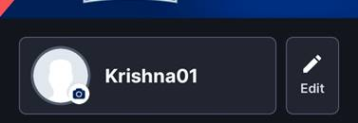
- Reduces User Effort: Eliminates the trial-and-error process of finding an available username.
- Enhances Onboarding Experience: Makes the sign-up process smoother and faster.
- Encourages Personalization: Users can still modify suggestions to match their preferences.
4. Fantasy Shop – Ensure the Fantasy Shop includes a Category and Filter functionality (Price/Coin/Point) to improve user navigation and shopping experience. Filters should be intuitive, easy to use, and dynamically update available items based on the selected criteria.
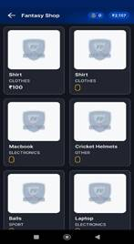
- Improves Discoverability: Users can quickly find relevant items without scrolling endlessly.
- Enhances Usability: A well-structured filtering system simplifies decision-making.
- Boosts Engagement & Sales: Makes the shopping experience smoother, encouraging more purchases.
5. Fantasy Shop: Add a ‘Notify Me’ option for out-of-stock items in the Fantasy Shop, allowing users to receive alerts when the item becomes available
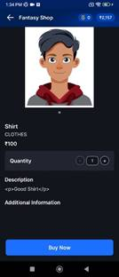
- Improves User Convenience: Users don’t need to keep checking manually.
- Increases Retention: Encourages users to return to the app when items are restocked.
- Boosts Sales: Keeps interested users engaged, increasing the chances of future purchases.
6. Withdraw: Enhance the withdrawal process by adding a ‘Withdraw via UPI ID’ option, allowing users to transfer funds directly to their bank accounts seamlessly. This will improve convenience, speed, and user satisfaction.

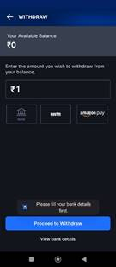
- Faster Transactions: UPI withdrawals are instant compared to traditional bank transfers
- Improved User Experience: Reduces the hassle of entering lengthy bank details.
7. Pop-ups: Ensure that pop-up sizes and dimensions follow design standards for optimal usability. Pop-ups should be responsive, non-intrusive, and well-positioned to maintain a seamless user experience.
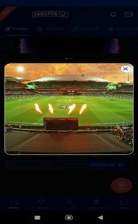
- Enhances Readability: Properly sized pop-ups ensure clear visibility of content.
- Improves Accessibility: Works well across different screen sizes and devices.

8. Change Password: Add an additional 'Reset' or 'Clear Data' button in the Change Password section, allowing users to easily clear entered data if needed.
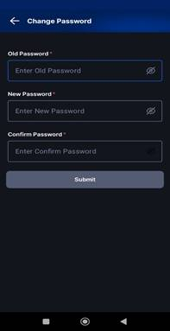
- Enhances User Convenience: Users can quickly reset fields without manually deleting text.
- Reduces Errors: Prevents accidental submission of incomplete or incorrect passwords.
- Improves UX Flow: Creates a smoother and more user-friendly password update process.
9. Edit Profile: Group related fields together in the 'Edit Profile' section to reduce unnecessary scrolling.
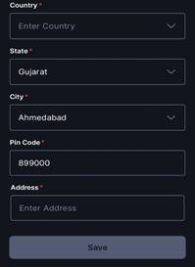
- Enhances Usability: Users can update information efficiently without excessive navigation.
- Reduces Cognitive Load: Organizing fields logically makes the process easier to understand.
- Improves Mobile Experience: Minimizing scrolling enhances accessibility on smaller screens.
10. Join Contest: Simplify the 'Join Contest' process by reducing steps and making the interface more intuitive. A short and clear flow will enhance user experience and encourage higher participation.
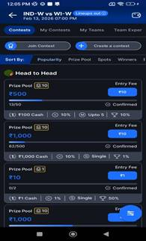
- Faster Participation: Users can join contests quickly without unnecessary steps.
- Reduces Drop-off Rate: A simple process prevents users from abandoning the action
- Enhances Engagement: A smooth experience encourages users to join more contests frequently.
11. Expert team: Ensure the 'Expert Team' page includes all relevant information to match the standards of competitor applications. Adding missing details will improve user trust, engagement, and decision-making.

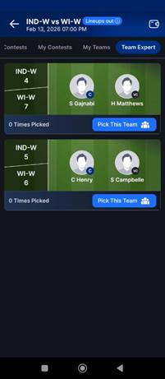
- Enhances User Confidence: Users rely on expert insights for better gameplay.
- Improves Competitiveness: Keeping features in line with other apps prevents users from switching.
- Provides a Complete Experience: A well-detailed page ensures users get all necessary information in one place.
12. Loyalty Point: Integrate the Loyalty Points display as an icon with a visible count instead of a separate field. This will save space, improve UI clarity, and provide a seamless user experience.
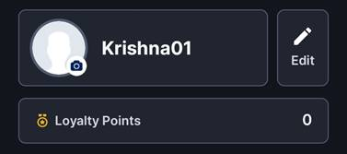
- Enhances UI Simplicity: Reduces clutter and makes the interface cleaner.
- Improves User Experience: Users can quickly view loyalty points without navigating extra fields.
- Saves Screen Space: Ideal for mobile-friendly and responsive design.
13. Notification: Remove the toast message after enabling or disabling notifications to prevent unnecessary interruptions.
( https://photos.app.goo.gl/G6ggGmMxjzTz9ZHf7 )
- Reduces Distractions: Prevents unnecessary pop-ups that disrupt user flow.
- Enhances UX Clarity: The toggle itself provides immediate feedback.
14. Alert message: Implement an alert message or validation prompt when a user accidentally attempts to close the app. This will help prevent unintended exits and improve user experience.
( https://photos.app.goo.gl/yo77Z33hAd9xTy9u8 )
- Prevents Accidental Exits: Avoids frustration from unintentional app closures.
- Enhances User Control: Gives users a chance to confirm their action.
- Improves Retention: Keeps users engaged instead of losing them due to accidental exits.
15. Notification – Optimize the scrolling experience in the Notification section to ensure smoother performance, matching industry standards.
( https://photos.app.goo.gl/onQZPZMJttXn842w7 )
- Reduces Lag & Frustration: Smooth performance keeps users engaged
- Enhances Competitiveness: Matches the quality of similar applications, preventing users from switching.

